SET 29 – STUDENT ACADEMIC PERFORMANCE
AIM
To analyze student academic performance using R programming and Tableau through area charts, boxplots, density plots, and interactive scatterplots.
DATASET
Student_ID | Age | Study_Hours | Attendance (%) | Test_Score | Participation_Score
S1 | 19 | 12 | 90 | 85 | 8
S2 | 21 | 8 | 70 | 70 | 7
S3 | 20 | 15 | 95 | 92 | 9
S4 | 22 | 10 | 85 | 80 | 8
S5 | 23 | 7 | 60 | 65 | 6
PROGRAM 1: Stacked Area Chart
Aim: To create an area chart showing test scores and participation scores across students.
R Program:
student <- c("S1","S2","S3","S4","S5")
test <- c(85,70,92,80,65)
part <- c(8,7,9,8,6)
data <- data.frame(student,test,part)
matplot(1:5, cbind(test,part),
type="l", lty=1, lwd=2,
col=c("blue","red"),
xaxt="n", xlab="Students",
ylab="Scores",
main="Student Performance")
axis(1, at=1:5, labels=student)
legend("topright",
c("Test Score","Participation Score"),
col=c("blue","red"), lty=1)
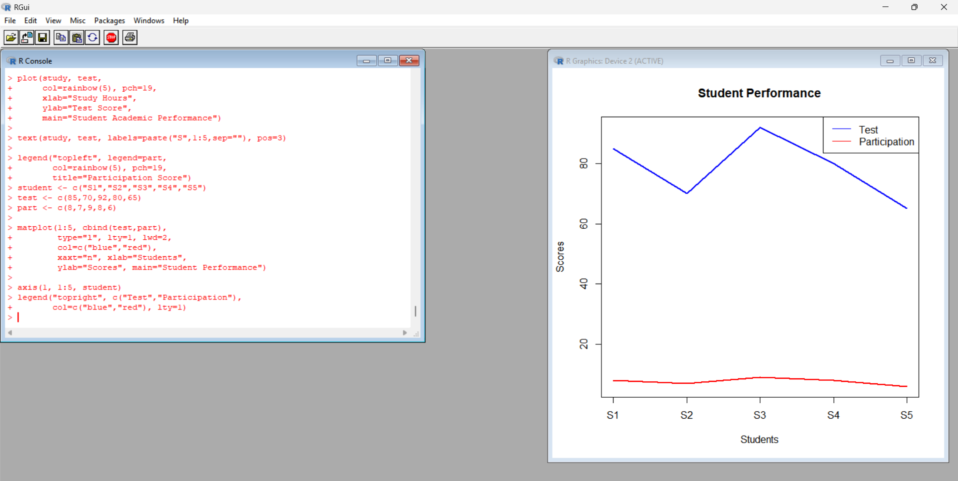
Observation: Student S3 has the highest test score of 92 and participation score of 9. Student S5 has the lowest test score of 65 and participation score of 6.
Result: The chart compares test and participation scores across students.
PROGRAM 2: Boxplot of Study Hours by Attendance Quartiles
Aim: To compare study hours across attendance quartiles using a boxplot.
R Program:
attendance <- c(90,70,95,85,60)
hours <- c(12,8,15,10,7)
q <- factor(c("Q3","Q2","Q4","Q3","Q1"),
levels=c("Q1","Q2","Q3","Q4"))
boxplot(hours ~ q,
col=c("skyblue","orange",
"lightgreen","pink"),
xlab="Attendance Quartiles",
ylab="Study Hours",
main="Study Hours by Attendance")
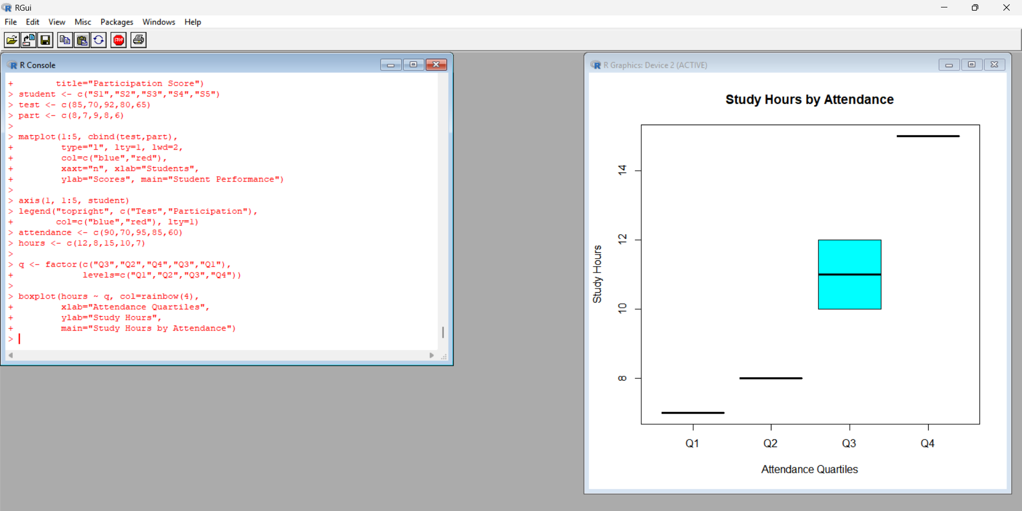
Observation: Q1 contains S5 with 7 study hours, Q2 contains S2 with 8 hours, Q3 contains S1 and S4 with 12 and 10 hours, and Q4 contains S3 with 15 hours. The highest attendance group also has the highest study hours in this dataset.
Result: The boxplot compares study hours across attendance groups. Groups with one observation do not have meaningful boxplot spread or IQR estimates, and outliers cannot be reliably assessed from these small groups.
PROGRAM 3: Density Plot of Test Scores
Aim: To visualize the distribution of student test scores and examine possible unusual values.
R Program:
scores <- c(85,70,92,80,65)
d <- density(scores)
plot(d, col="blue", lwd=2,
main="Density Plot of Test Scores",
xlab="Test Score",
ylab="Density")
rug(scores)
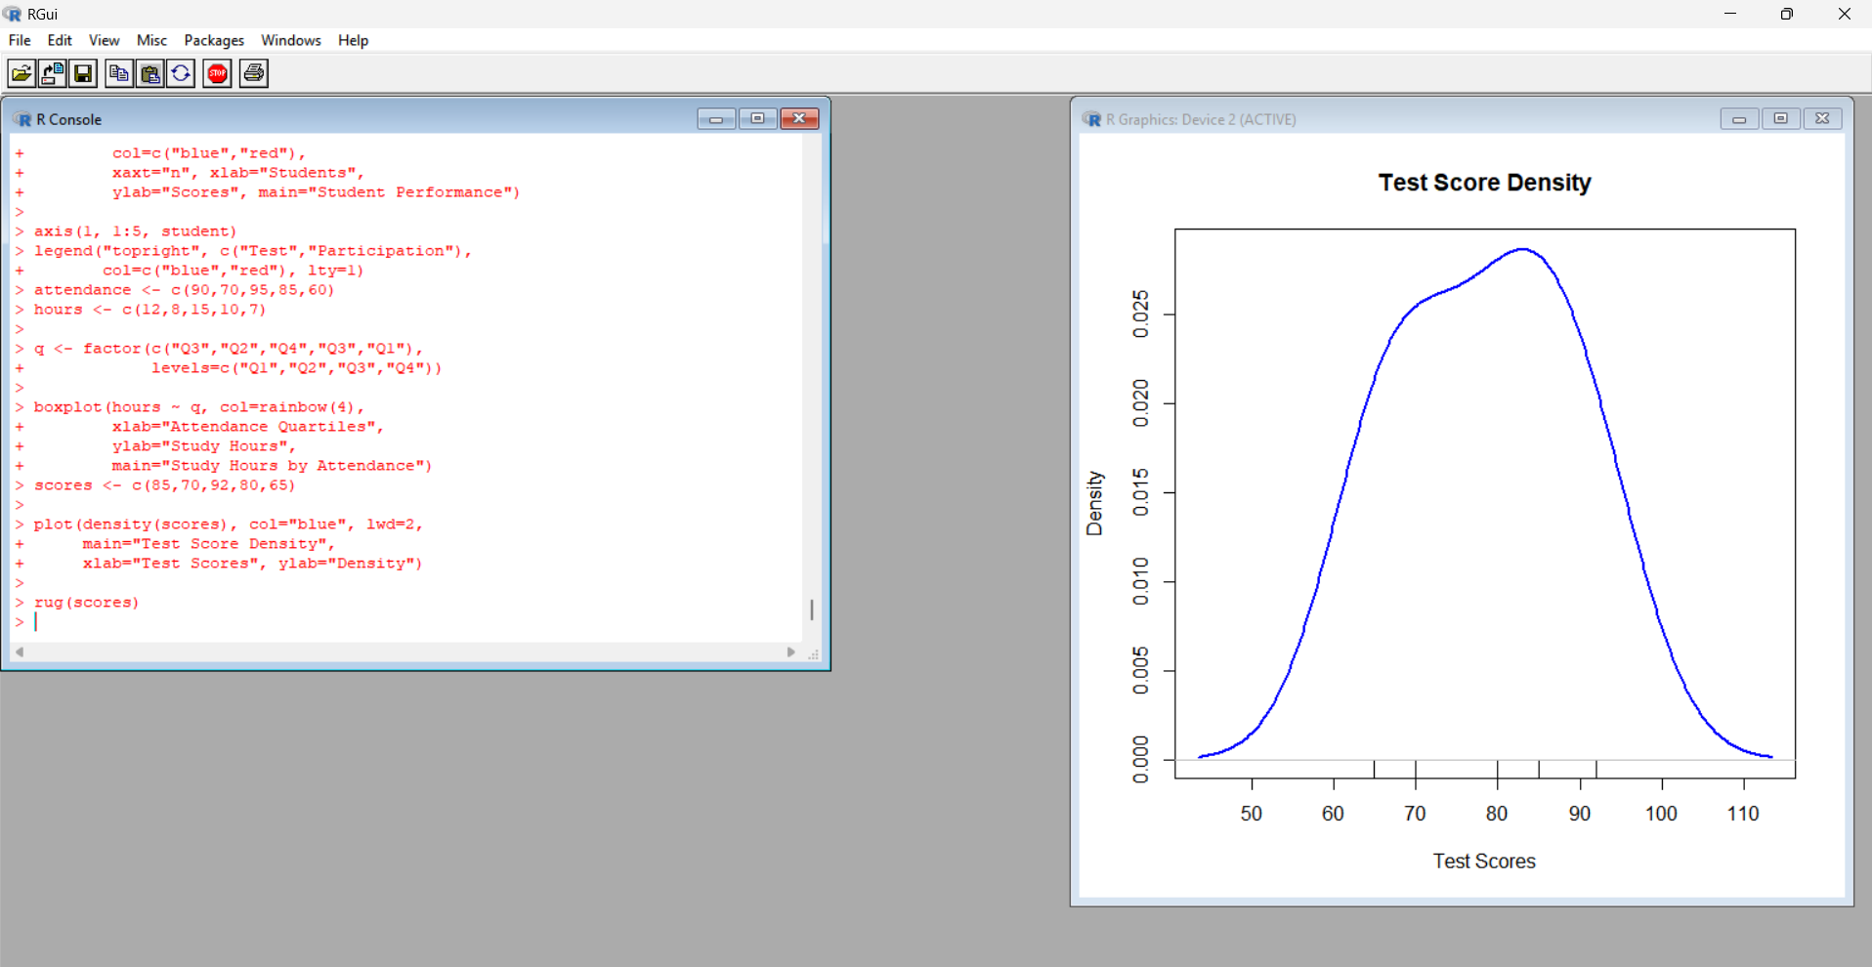
Observation: The scores range from 65 to 92. The density curve shows the distribution of the five scores. No clear outlier can be established from this small sample alone.
Result: The density plot visualizes the distribution of test scores.
PROGRAM 4: Interactive Scatterplot Using Tableau
Aim: To create an interactive scatterplot showing the relationship between study hours and test scores, with participation score represented by color and age used as a filter.
Procedure:
- Enter the dataset into Excel and save it as Student_Academic_Performance.xlsx.
- Open Tableau and connect to the Excel file.
- Drag Study_Hours to Columns.
- Drag Test_Score to Rows.
- Select Circle from the Marks card.
- Drag Participation_Score to Color.
- Drag Student_ID to Detail.
- Drag Age to Filters and select Show Filter.
- Add the title Student Academic Performance Dashboard.
- Adjust colors and labels to make the chart clear.
Observation: Student S3 has the highest study hours (15) and test score (92). Student S5 has the lowest study hours (7) and test score (65). The results suggest a positive relationship between study hours and test scores in this dataset, but the sample is too small to establish a general conclusion.
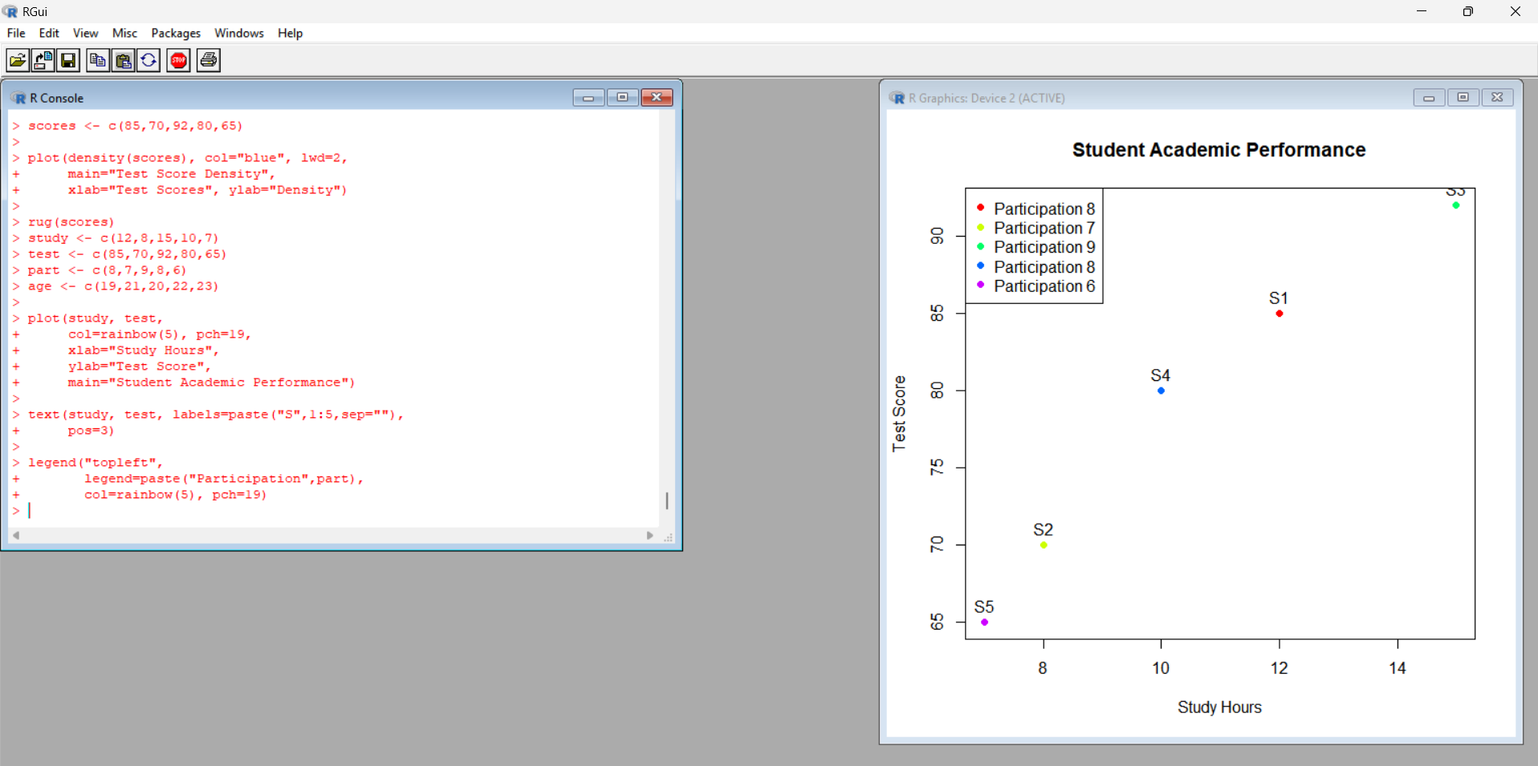
Result: An interactive Tableau scatterplot is designed to compare study hours, test scores, participation scores, and age.

